Name:______________________
Tables 14th January 2019
How many correct answers can you get in 2 minutes? Record your results in the box below each day and try to beat your own score.

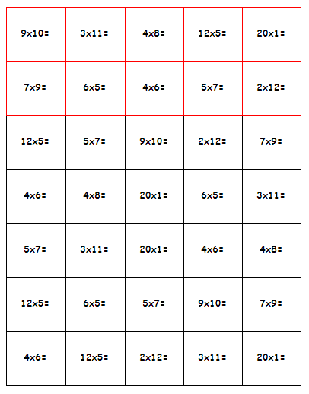

Monday | Tuesday | Wednesday | Thursday

